Project Title
Your Name
Saint Mary's University of Minnesota
Schools of Graduate & Professional Programs
Course Name and Number (e.g., PRM 600)
Instructor's Name
Date of Submission (e.g., October 12, 2017)

Table of Contents
Instructions for Working with Templates 2
Initiating Process Group 2
01a Project Context 2
01b-Business Case 4
4.1a Project Charter 5
PMBOK® Guide Chapter 5 – Project Scope Management 8
5.1 Plan Scope Management 9
5.2 Collect Requirements 10
5.3 Define Scope 11
5.4 Create WBS 13
5.5 Validate Scope 16
5.6 Control Scope 17
PMBOK® Guide Chapter 6 - Schedule Management Processes 18
6.1 Plan Schedule Management 19
6.2 Define Activities 19
6.3 Sequence Activities 20
6.4 Estimate Activity Durations 22
6.5 Develop Schedule 24
6.6 Control Schedule 26
PMBOK® Guide Chapter 7 – Project Cost Management 27
7.1 Plan Cost Management 28
7.2 Estimate Costs 28
7.3 Determine Budget 29
PMBOK® Guide Chapter 4.2.3.1 – Change Management Plan and 4.6 Perform Integrated Change Control 31

Instructions for Working with Templates

- Work directly in copies of the templates
- Replace all instances of “Your text here” with your own project information.
- Each table has a header row that is automatically repeated when the document spans additional pages.
- Keeping a line of text between tables (boxes) will avoid problems with tables accidentally merging and potentially disappearing, which is a known issue with Microsoft Word tables.
- You and your team may choose to move the templates to Google Docs or Google Drive to facilitate collaboration.

Initiating Process Group
According to PMI (2017) “the initiating process group is performed “to define a new project or a new phase of an existing project by obtaining authorization to start” (p. 561). The key benefits are that “only projects that are aligned with the organization’s strategic objectives are authorized, and that the business case, benefits, and stakeholders are considered from the start of the project” (p. 561).

The initiating processes begin with locating or creating documents that characterize key elements of the project environment. Without sound documentation of the rationale for the project and an assessment of the environment in which the project will occur, it is impossible to determine a project has been completed correctly.

Initiating Process Group
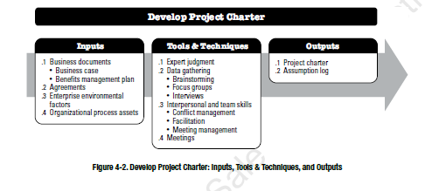

01a Project Context
01a Project Context-Chapter 1 and Project Environment Chapter 2
Chapter 1 includes an overview of the project management context.
Project Definition
Describe how this project meets the criteria of being “a temporary endeavor undertaken to create a unique product, service or result (p. 4)
The Lyle Public Schools Interior Repaint project is a short-term project to enhance the condition and aesthetic of the interior of the school buildings. The project includes repainting areas of the buildings that have deteriorated over time, including hallways, the gymnasium, and entranceways, among others. This initiative is a project because it has a clear timeframe with a beginning and an end, has defined objectives, and has a scope that is different from other maintenance work. The repainting will not be an ongoing process once it is implemented, so this also supports the fact that this is a project.

Operations Management
Describe how this project is integrated with the ongoing operations of the performing organization (p. 16)
This project needs to fit around the normal operations of the school to minimize interruptions to teaching and learning. Schools have a strict schedule, and painting needs to be coordinated to occur during periods of low occupancy, such as weekends, holidays, or afternoons. This project will need to be closely coordinated with the school management to ensure secure access to all areas of the building and to keep the school safe. By incorporating the project into the schools' operations in this way, we ensure that the work is undertaken without affecting critical operations.

Project and Development Life Cycle (LC) (p. 19-20)
Select the project lifecycle most appropriate for this project, and explain why it fits that definition. The choices are:
This project is both planned and executed using a hybrid approach. The majority of the project is designed ahead of time with planning for what area to paint, the type of material, and a schedule. But a bit of flexibility is needed during implementation as the site conditions may not be as planned. This could be because clean-up work is needed or access to the area is delayed. Planning and flexibility working together this way allow the project to advance when unforeseen circumstances occur.

Phases and Phase Gates (p. 20-21)
If the project will be divided into phases, name each phase, and identify the phase gate entrance and exit criteria
- The first phase is planning, in which the project scope, schedule, and resources are planned and approved
- In phase two, procurement, all materials and equipment are bought and set for installation
- The third phase is implementation, which involves prepping, painting, and finishing
- The last phase is inspection and closure, involving assessment of the work that has been done and completion of documentation
Tailoring
Describe any methodologies that will be applied to the project and the unique characteristics of the project that make tailoring necessary (p. 28)
Your text here

Chapter 2 describes the environment in which projects operate
EEF- Enterprise Environmental Factors
Describe any EEF in the project environment that may enhance or constrain project management options. (p. 38-39)
There are a number of external influences that can have an impact on the project. This can include school holidays, which restrict the time that work can be carried out, and safety rules to be followed when painting. The project's budget may also affect the purchasing of materials and the hiring of workers. Also, indoor environmental factors such as air quality need to be taken into account. Skilled employees and availability of materials may also affect the project timeline.

OPA – Organizational Process Assets (p. 40—41).
Describe the types of assets available to the project team for this project.
The project is supported by the organizational assets in the form of previous maintenance history, standard procurement processes for materials, and safety standards. Documentation and reporting templates are also provided, which ensure uniform information reporting and documentation. These resources enable the project team to draw on the experience of best practices and avoid mistakes during planning and implementation.

Governance Framework
Describe the effects of the organization’s governance framework on this project. (p. 43-44)
The governance of the school is crucial for the project. Budget allocation, procurement, and final sign-off on the work are managed by the school administration. This helps to ensure that the project aligns with the school’s policies and that appropriate accountability is maintained. Ongoing monitoring also ensures that the project is high quality.

General Management Elements
Describe the general management elements that should be evaluated in planning this project and explain why they are important (p. 44-45)
Your text here

Organizational Structure
Describe the organizational structure within which the project will be conducted, and explain how that impacts the project characteristics, such as: (p. 46-47)
Work group arrangement:
Project manager’s authority and role:
Resource Availability:
Who manages the project budget:
Project mgmt administrative staff:

Project Management Office (PMO)
Describe the type of PMO, if any, at the organization, determine which type of PMO it is, and evaluate how the PMO may be a factor in managing your project. (p. 48-49)
Your text here

01b-Business Case
01b -Business Case (PMI, 2017, pp. 30-32
The Business Case is “a documented economic feasibility study… It lists the business objectives and reasons for project initiation” (p. 30)

1.0 Introduction/Background
Describe the sponsoring organization and the proposed project environment.
The Lyle Public Schools Interior Repaint project has been proposed to replace the paint in the school buildings. The paint has worn out and become chipped and damaged over time, impacting the appearance and cleanliness of the space. This project will repaint these surfaces and improve the appearance and appropriateness of the environment for students, teachers, and visitors.
1.0 Business Needs
1.1 Current Situation and Problem/Opportunity Statement
What is prompting the need for action? Provide a brief (2-3 sentence) overview. What is the problem that needs to be solved or the opportunity that can be captured?
This project is needed because the present appearance of the interior of the school is unacceptable. Old and damaged surfaces can contribute to a general sense of wear and tear in the learning environment and have the potential to pose small safety issues. Through the process of repainting these surfaces the school can enhance the quality of its spaces and the environment for its users.

2.0 Analysis of the Situation -(PMI, 2017, pp. 77-78)
What factors were considered significant and resulted in this business plan being created (check all that apply, and briefly explain what the factor is in this project)
___ Market demand
___ Organizational need
___ Customer request
___ Technological advance
___ Legal requirement
___Ecological impacts
___social needs

2.1 Business Objective:
What mission or strategic plan of the organization is this related to?
How does the project connect to the mission of the sponsoring organization?
The project aims to upgrade the physical environment of the internal spaces of the school in order to support its teaching and learning activities. The project enhances the larger objective of offering a safe and productive environment for learning through a clean and more aesthetic environment.
2.2 Project Initiation Context and Root Cause (PMI, 2017, p. 7-8).
Which of the four categories of factors driving change does this fall into and why?:
a) Meet regulatory, legal or social requirements,
b) Satisfy stakeholder requests or needs,
c) implement or change business or technological strategies, or
d) create, improve or fix products, processes, or services.

The project will primarily focus on the need to upgrade existing facilities that are worn out. Rather than waiting to see what will happen, the school is taking a proactive approach to repair and maintain its buildings.

3.0 Alternatives
Describe three separate alternatives that could resolve the problem or capture the opportunity in order to meet the organizational objective. These might include: 1. Do nothing, 2. Do something to partially solve the problem, or 3. Do something to fully address all the problems or opportunities. These could also be three different technical solutions, or three different approaches. You will recommend one of the three alternatives as your project.

There are three possible options for dealing with the depreciation of the school's interior. The first alternative is to do nothing, which would prevent initial costs, but would continue to allow the paint to fail, resulting in a poor teaching and learning environment, as well as potential health and safety risks in the future. The second alternative is to paint isolated areas of high priority (such as corridors and entrances), which would be cost-effective in the short term but would be irregular in appearance and require further work in the future. The third option is to fully repaint all of the interior areas affected, which would result in a consistent appearance, better durability and a more effective long-term solution.

4.0 Recommendation
Indicate which of the three alternatives you are recommending. Explain why this alternative is better than the others. Use either Section 5.0 or Section 6.0 to support your analysis.
The best option is the repainting of all interior rooms as it provides a permanent solution to the problem. It costs more up front than repainting certain areas of the school, but it minimizes the need to undertake further work in the future and achieves a consistent appearance. It also aligns with the school's desire to have a clean, safe and healthy environment and is thus more cost-beneficial in the long run.

6.0 Financial Analysis (Optional)
Evaluate the return on investment for the proposed project using IRR, ROI, Cost Benefit Analysis or another financial technique. Explain the technique and its results here.
According to Figure 2, the best decision is: The project is analyzed using basic cost-benefit analysis. The total repaint has higher initial costs, but it will likely last longer, thus decreasing the need for future repainting. This results in lower costs in the long run. On the other hand, the partial repaint may be more cost effective in the short term but will be less cost effective in the long term. Under these circumstances, the full repaint is better value for money. Based on the results in Figure 2, the decision should be to opt for full repaint.
7.0 Preliminary Project Requirements
How will you know when you have successfully completed the project? List 5 measurable results.

The project will be deemed a success if the following outcomes are met:
The entire interior spaces identified will be repainted to the specified finish.
Quality inspection of the completed work is successful with no major defects.
The works are delivered within the allocated budget.
The project is completed on time.
Appropriate approval is sought and gained from school administration.

4.1a Project Charter
4.1a Project Charter
The Project Charter “formally authorizes the existence of a project and provides the project manager with the authority to apply organizational resources” (p. 74) and documents initial requirements. Multiple charters may be used to validate or refine decisions made for multi-phase projects.

Inputs to the Project Charter
What data was collected to prepare to write the project charter? This may include: business documents, agreements, EEFs or OPA. Explain how each was collected and why it is important to developing the project charter.
The project charter development is based on the business case, which justifies repainting, and past project data of other maintenance works, which gives an indication of costs and time. The company's rules and regulations and safety standards were also consulted. Furthermore, meetings with school administrators provided information on project needs. These are important as they help to craft the project objectives, scope and limitations.
Tools and Techniques Used to Develop the Project Charter
What tools and techniques were used to develop the project charter? How was each of these tools specifically applied to produce the charter? Tools and techniques often include expert judgement, data gathering, interpersonal and team skills and meetings.
Expert judgment was used to draft the project charter, with input from experienced people (or contractors and facility managers) to determine the time, cost and resources needed for the project. Information was also gathered and goals agreed to in meetings with stakeholders. Simple data analysis techniques were applied to review historical data from previous projects to determine present needs. These techniques helped to ensure the charter is realistic.
High-level Project Description
Describe the project and its major deliverables and boundaries in a sentence or two that can be said in less than 30 seconds.
The project will provide a painting job for the interior areas of Lyle Public Schools (prep, paint, inspect and document) for a period for a price.

Project Objectives
What will the project produce? How will we know that the project objectives have been successfully accomplished?

The desired outcome of the project is a newly painted interior with enhanced aesthetic, safety and durability. The project will be judged by the completion of work, inspection, adherence to budget and schedule.
The following key deliverables or success criteria will be used to demonstrate accomplished objectives.
Deliverables will include the surfaces repaired and painted, inspection reports, and project documentation.
Pre-approved Financial Resources $
How much will the project cost? How much spending should be authorized on this project? Explain some of the major cost elements.

An estimated $50,000 is needed for the project. The primary expenses include staffing costs (painters), materials costs (painting, supplies), equipment hire, and contract administration costs.

Summary Project Milestone Schedule
On what date will each key event happen? What deadlines are known? How will we know progress is being made?

Major milestones will be the end of planning (May 1), arrival of materials (May 5), completion of painting (May 27), and inspection and approval (June 1). The project's progress will be tracked through these reports and milestones.
Key Stakeholder List
Who are the key stakeholder individuals or groups?

The school administration, project manager, contractor, painters, students, staff, and PMO are all key stakeholders.
Project Approval Requirements
“Who decides whether the project has been successful?” (p.81) What are the top 3 benefits?

Success of the project will be judged by the school administration. The main advantages are that it looks better, is safer, and the interior will last longer.
Project Exit Criteria
“What are the conditions to be met to close or cancel the project?” (p. 81)

The project will be closed when all painting is complete, inspections are approved, final documentation is complete, and all stakeholders have given final approval.
Assigned Project Manager, Responsibility and Authority Level
Who is/ will be assigned to manage? What are they authorized to approve for spending, leading, etc?

Project Manager: Plans, coordinates work, and tracks progress; has authority to make decisions about day-to-day project activities.

Authority level: School administration authorizes the project and provides funding and final sign-off.
Name and Authority of the Sponsor or other persons authorizing the project charter

Your text here

PMBOK® Guide Chapter 5 – Project Scope Management

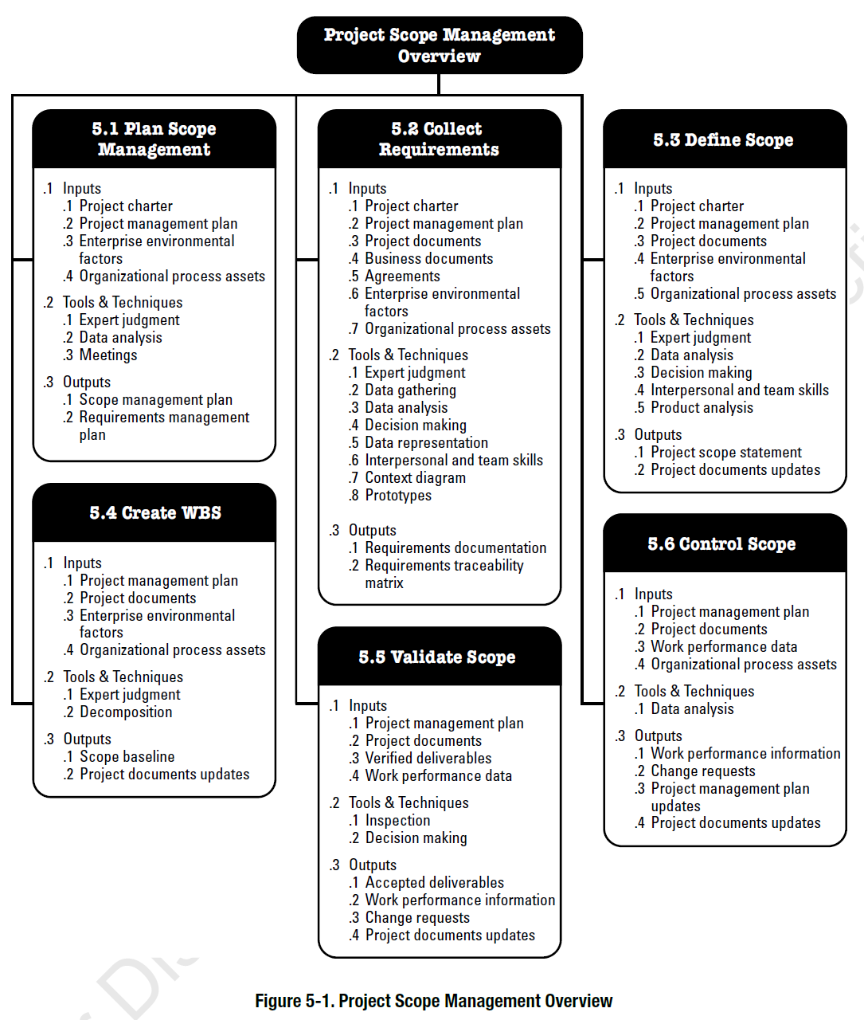

5.1 Plan Scope Management

5.1a Scope Management Plan
The Scope Management Plan describes how the scope will be defined, developed, monitored, controlled and verified.
Inputs Used
Identify specific inputs needed before the Scope Management Plan and the Requirements Management Plan can be created.

The inputs that will be utilized to come up with the scope management plan are the approved project charter, which outlines the purpose, objectives, and the general limits of the project. The business case was also studied to know why they needed to repaint and the anticipated savings. School administrators and maintenance staff were interviewed as stakeholders to get their input so that their requirements were well understood. Further, planning and decision-making were made based on organization guidelines and maintenance history

Tools and Techniques Used
Identify the tools and techniques used to create the plans. Explain how you used the tools.

Stakeholder meetings were held to get requirements and validate expectations. Scope details and identifying potential challenges were estimated by expert opinion of the experienced contractors. Similar past projects were also reviewed using document analysis to implement lessons learned to plan better.

Output: The Scope management plan provides a process for preparing a detailed scope statement and a WBS, and processes to manage changes and to track acceptance of deliverables.

A scope management plan describes the scope definition, development, monitoring, and controlling of the project scope. It describes how to develop an elaborate scope statement and a work breakdown structure. It also outlines the process of scope changes being reviewed and approved and how deliverables will be checked prior to acceptance.

Output: The Requirements Management Plan provides a process for determining how requirements will be planned, tracked and reported. The consultants will help implement a process for prioritizing requirements, managing changes to requirements, and using a traceability matrix and developing metrics.

It elaborates on how the requirements will be given priority, change will be handled, and each requirement will be traced to deliverables to ensure all expectations are fulfilled.

5.2 Collect Requirements

5.2a. Requirements Documentation
This table describes how individual requirements meet the business need for the project. During early planning stages, requirements are defined at a high level and become progressively more detailed during project execution. Requirements must be unambiguous so that they can be traced.
Stakeholder  (group)  Person / group that will approve or accept a deliverable | Requirement  Describe a part of the product that will be delivered such as a document, service, product or result. | Acceptance Criteria  Describe how the stakeholder will evaluate the finished element. | Priority (HML)  Category  Select High, Medium or Low for priority level. | ID #
PMO | Project Baselines for Scope, Cost and Schedule | The senior member of the PMO will sign off on the baselines if they meet criteria for level of detail and attainability. | High | R1
School Administration | Interior spaces | This will be condoned provided that all surfaces are well painted and are visually inspected | high | R2
Maintenance Dept | All Materials | All materials are checked before using | medium | R3

5.3 Define Scope

5.3a Define Scope
The primary outcome of the Define Scope process is the Project Scope Statement that provides a common understanding of the project scope among all stakeholders and provides a baseline for evaluating whether requests for changes or additional work are inside or outside the project’s boundaries.
Description of the Product
Describe the end product, service or result that the project will produce.

The project will create a complete interior environment of Lyle Public Schools, such as hallways, gymnasiums, and entrances, to be repainted, which will make the environment look better and have longer lives.

Product Acceptance Criteria
Describe how the stakeholder will accept the final product.

Once every area is fully painted, surfaces are smooth and without defects, and the work is of agreed quality as established by inspection, then the project will be accepted.
Project Deliverables

The deliverables will be painted interior surfaces, inspection reports, and final project documentation.
Project Exclusions
Describe any items stakeholder may have considered that are outside of the project boundaries.

The product specifically excludes : Only the interior repainting is included in the project, and no exterior painting will be done; structural repairs or any form of renovation will be included in the project.

Project Constraints
List any factors that limit the options available to the project team.

Constraints include: The limitations are a tight budget, a fixed time, insufficient access to specific zones during school days, and adherence to safety rules.

Project Assumptions
List any factors that were assumed in project planning, and indicate what may happen if it turns out that these assumptions were false.

It is assumed that materials would be in place as and when. In case this is not the case, there will be delays.

It is also presumed that work areas will be opened as scheduled. In case the latter is not the case, then the timeline can be adjusted.

5.4 Create WBS

5.4a WBS – Work Breakdown Structure
The WBS is a hierarchically oriented description of all the product and project deliverables included in the project. It does not include tasks or activities.
Levels: Level 0 has one element – the main product of the project. Level 1 has up to eight elements or categories and is numbered 1, 2, 3 etc. Level 3 has up to eight elements per category from level 2 and defines specific deliverables for which completeness, and quality and date of delivery can be specifically defined.
Elements at this lowest level of the WBS are defined as work packages and each one will be less than 5% of the total project cost, will take 1-2 weeks to complete, and can reasonable be completed by a small group. Work packages can be scheduled, cost estimated, monitored and controlled.

Level 0 : Product of the Project - Repainting of Lyle Public Schools' interiors.
Level 1 (Major Deliverables)
- Major Deliverable 01 - Planning and Preparation
- Major Deliverable 02 - Procurement of Materials
- Major Deliverable 03 - Surface Preparation
- Major Deliverable 04 - Painting
- Major Deliverable 05 - Inspection and Completion
- Project Management - Project Management

Level 2
1 (Major Deliverable 01) – your text here – same as above.

1.1 Deliverable: - Scoping
- 1.1.1 Work package - scheduling
- 1.1.2 Work package - resource definition
- 1.1.3 Work package - planning
- 1.1.4 Work package - your text here

1.2 Deliverable - Procurement
- 1.2.1 Work package - Purchasing of materials
- 1.2.2 Work package - your text here
- 1.2.3 Work package - your text here

Level 2
2 (Major Deliverable 02) Surface preparation

2.1 Deliverable: - cleaning
2.2 Deliverable: - repairing
2.3 Deliverable – your text here

Level 2
3 (Major Deliverable 03) Painting

3.1 Deliverable: - coats
3.2 Deliverable: - finishing
3.3 Deliverable – your text here

Level 2
4 (Major Deliverable 04) checking

4.1 Deliverable: - quality checks
4.2 Deliverable: - approval
4.3 Deliverable – your text here

Level 2
5 (Major Deliverable 05) Project Management

5.1 Deliverable: - coordination
5.2 Deliverable: - reporting
5.3 Deliverable – control

Level 2
6 Project Management. (feel free to add any elements here).

6.1 Initiating documents – charter, stakeholder analysis
6.2 Closing– lessons learned meeting, documents archived.
6.3 Executing
6.3.1 weekly project team meetings,
6.4.1 weekly status reports
6.4 Planning documents
6.4.1 Approved Baselines for scope, schedule and cost
6.4.2 Planning documents for each knowledge area.
6.5 Project Oversight – monitoring and control and oversight of all project activities.
6.5.1 weekly status reports
6.5.2 Semi-monthly meetings with the PMO

5.5 Validate Scope

5.5a Validate Scope
Validate Scope is the process of formalizing acceptance of the project deliverables.
Inputs Used
Identify specific inputs needed before validating scope can occur.

Finished deliverables, inspection outcomes, and the approved scope baseline are inputs.

Tools and Techniques Used
Identify the tools and techniques used to executing this process. Explain how you used the tools.

Work inspection and audit by stakeholders are meant to ensure that the work is up to standard.

Output: Identify the deliverables that will be accepted once the process is completed.

Formal acceptance of work done by the school administration is the output.

5.6 Control Scope

5.6a Control Scope
Validate Scope is the process of formalizing acceptance of the project deliverables.
Inputs Used
Identify specific inputs needed before control scope can occur.

Your Text Here: The scope baseline, performance reports, and change requests are the inputs.
Tools and Techniques Used
Identify the tools and techniques used to executing this process. Explain how you used the tools.

Your Text Here: To keep the project within the scope, progress monitoring and review of change requests are employed.

Output: Identify the outcomes once the process is completed.

Your Text Here: Outputs encompass approved amendments and revised documents as well as managed project implementation.

PMBOK® Guide Chapter 6 - Schedule Management Processes
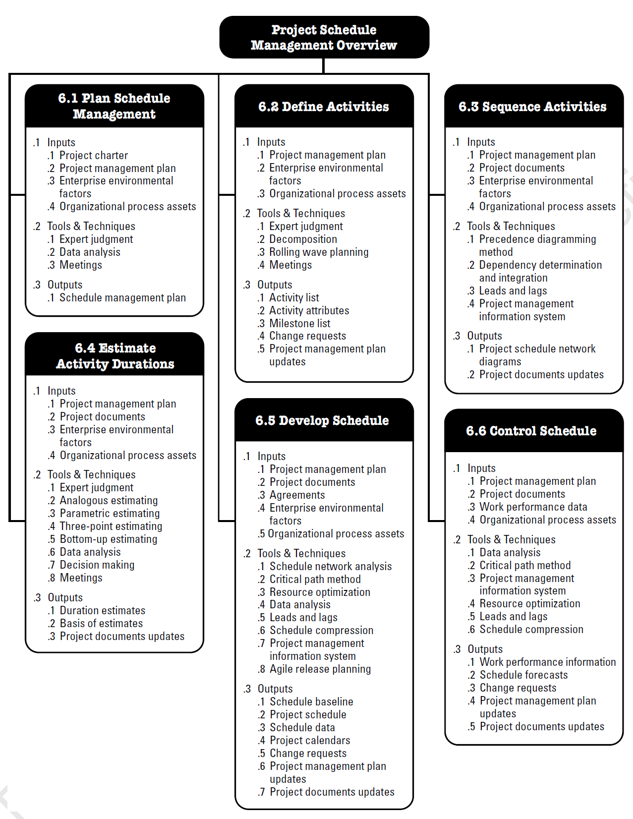

6.1 Plan Schedule Management

6.1 Schedule Management Plan
The Schedule Management Plan describes how the schedule will be defined, developed, monitored, controlled and verified.
Inputs Used
Identify specific inputs needed before the Schedule Management Plan and the Requirements can be created.

Your Text Here: These inputs are the project charter, scope statement, and stakeholder requirements.

Tools and Techniques Used
Identify the tools and techniques used to create the plans. Explain how you used the tools.

Your Text Here: The schedule was developed using scheduling tools, expert judgment, and planning meetings.

Output: The Schedule Management Plan provides a process for preparing a detailed process plan for developing the project schedule.

Your Text Here: The result is a schedule of the tasks that specifies their timing and order.

6.2 Define Activities

6.2a Milestone List
The Milestone list defines all the milestones and the nature of each one. It describes the nature of the milestone
Inputs Used
Identify specific inputs used to identify the milestones and the nature of the milestones.

Your text here : painting, cleaning surfaces,

Tools and Techniques Used
Identify the tools and techniques used to identify the milestones and the characteristics of the milestones. Explain how you used the tool.

Your text here: Ms Project to schedule the start and end dates

INCLUDE ALL MILESTONES
WBS ID  (opt) | Milestone | Date  Ie. May 1, 2013.) | Characteristics  What document or other deliverable will be used to determine that the milestone has occurred?
 | 1 Planning done | June 1 | Approved project plan
 | 2 Purchased materials received | June 5 | Materials received
 | 3 Work finished | June 27 | Painting completed.
 | 4 Inspection done | July 1 | Approved inspection.
 | 5 Project closure | July 3 | Final documentation.

6.3 Sequence Activities

6.3a Activity List with Dependency Attributes
Purpose of the Activity List
The Activity list defines all the activities needed to complete the project work at a level of detail so that the person performing the work understands how to complete the work.
Inputs Used
Identify specific inputs used to identify the dependencies.

Your text here; Ms Project

Tools and Techniques Used
Identify the tools and techniques used to generate a list of the activities and their characteristics (columns). Explain how you used the tool.

Your text here: I used Ms project to enter the activities and determine dependencies.

ONLY FIRST TEN LINES OF MS PROJECT FILE
WBS ID | Activity | Description of Work | Relationships  predecessors, lead or lag, successors, type of relationship  (FS, SS, or FF) | Imposed Dates, Constraints or Assumptions
1 | Preparation and logistics of the project. | Preparation and logistics of the project. | none | 12 days
2 | Planning and Site Assessment. | Planning and Site Assessment. | none | 5 days
3 | Check on all painting sections. | Check on all painting sections. | none | 1 day
4 | Accept paint and material specifications of color. | Accept paint and material specifications of color. | 3 | 1 day

6.4 Estimate Activity Durations

6.4a Activity List with Resource Attributes-
The Activity list with Resources defines all the resources needed to complete each activity to complete the project work including the duration and the effort needed for each activity.

Inputs Used
Identify specific inputs used to identify the activity resource attributes

Your text here: Ms Project
Tools and Techniques Used
Identify the tools and techniques used to generate a list the resource attributes. Explain how you used the tools.

Your text here: Ms Project

FIRST TEN LINES OF YOUR MS PROJECT FILE
WBS ID | Activity | Duration  Difference between start date and end date | Effort  # of hours actively engage in work | Resources  # of people | Skills  Level and type of skills needed | Materials Required  (equipment or supplies)
1 | Preparation and logistics of the project. | 12 days | 12 days | 3 | Reading and writing | Books, accounts
2 | Planning and Site Assessment. | 5 days | 5 days | 3 | Observation | People
3 | Check on all painting sections. | 1 day | 1 day | 2 people | observation | People
4 | Snapshots of the status quo. | 1 day | 1 day | 2 people | photography | camera

6.4b Resource Summary
In preparation for the human resources section, sum the hours required for each role (skill set).

Inputs Used
Identify specific inputs used to identify the activity resource attributes

Your text here

INCLUDE ALL WORK RESOURCES FROM THE MS PROJECT RESOUCE SHEET
ID | Role | Skill Set | # of persons to be assigned | Total hours of effort needed of  this skillset
R1 | Project Manager | Planning, monitoring, controlling, interpersonal skills | 1 | 36
R2 | Painters | In charge of the work of painters | 20 | 500
R3 | Laborers | preparation and support. | 10 | 500
R4 | Inspectors | In charge of quality checks. | 3 | 36

6.5 Develop Schedule

6.5a Schedule Baseline
Purpose of the Schedule Baseline
The Schedule Baseline list defines all the activities needed to complete the project work and identifies the start and end date of the activity in relation to all the other project activities. The baseline is usually maintained at a summary rather than a detailed level. The schedule baseline may be shown as a table or a GANTT chart or a network diagram.

FIRST TEN LINES OF MS PROJECT FILE
Activity or Milestone | ID | Dur-ation | Depends  On Activity or Milestone  (FS, SS, FF)  (Ex. B FS) | Earliest Start Date | Earliest End Date | WBS ID
Preparation and logistics of the project. | A | 12 days | 0 | Mon 4/27/26 | Tue 5/12/26 | 1
Planning and Site Assessment. | B | 5 days | 0 | Mon 4/27/26 | Fri 5/1/2 | 2
Check on all painting sections. | C | 1 day | 0 | Mon 4/27/26 | Mon 4/27/26 | 3
Accept paint and material specifications of color. | D | 1 day | C | Tue 4/28/26 | Tue 4/28/26 | 4

6.6 Control Schedule

5.6a Control Schedule
Validate Scope is the process of formalizing acceptance of the project deliverables.
Inputs Used
Identify specific inputs needed before control schedule can occur.

Your Text Here: Baseline and progress reports.
Tools and Techniques Used
Identify the tools and techniques used to executing this process. Explain how you used the tools.

Your Text Here: Time tracking and tracking.
Output: Identify the outcomes once the process is completed.

Your Text Here: New timetable and managed development.
PMBOK® Guide Chapter 7 – Project Cost Management
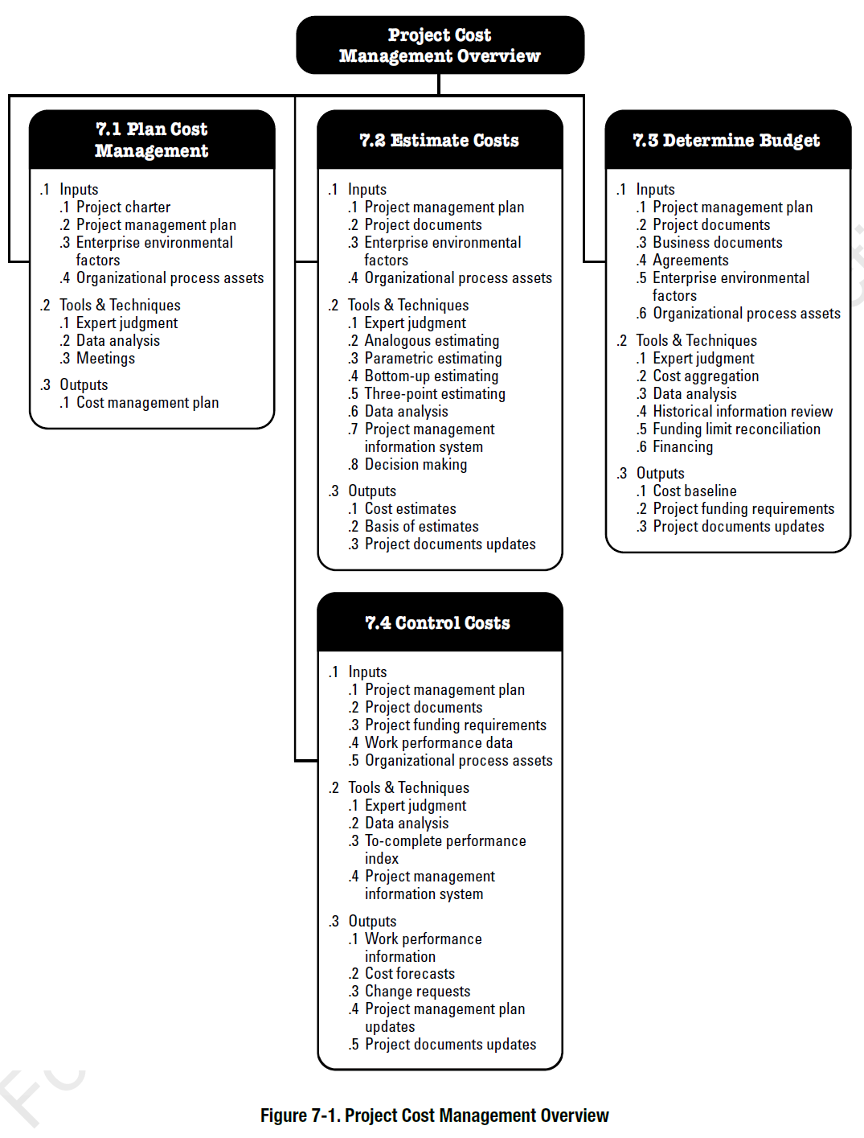

7.1 Plan Cost Management

7.1a Cost Management Plan
The Cost Management Plan defines how the project costs will be estimated, budgeted, managed, monitored and controlled. .
Inputs Used
Identify specific inputs needed before the Cost Management Plan will be created.

Your Text Here: Scopes and resources Project charter Project scope Project resource requirements
Tools and Techniques Used
Identify the tools and techniques used to create the plans. Explain how you used the tools.

Your Text Here: Expert judgment and cost estimation techniques.
Output: The Cost Management Plan provides a process for preparing a detailed process plan for developing the project budget. .

Your Text Here: An outline of a project cost management plan.

7.2 Estimate Costs

7.2a Estimate Costs
The Activity Cost Estimates are quantitative assessments of the probable costs required to complete project work.
Inputs Used
Identify specific inputs used to identify the costs of labor, labor rates, Equipment, material , supplies, indirect costs and travel.

Your text here: They are labor, material, equipment, and indirect costs.
Tools and Techniques Used
Identify the tools and techniques used to generate the cost of each of the activities and their characteristics (columns). Explain how you used the tool.
Your text here : It is estimated using past projects and prices of suppliers.
FIRST TEN LINES OF YOUR MS PROJECT FILE
WBS ID | WBS Description | Sum Total Estimate | Labor Hours | Labor Rates | Total Labor | Equip, Material, Supplies | Indirect Costs | Travel
1 | Preparation and logistics of the project. | $ 100  - | 40 | 25 | 1000 | 500 | 150 | 50
2 | Planning and Site Assessment. | $ 100 - | 35 | 25 | 900 | 200 | 100 | 50
3 | Check on all painting sections. | $ 100 - | 10 | 35 | 875 | 150 | 100 | 25
4 | Accept paint and material specifications of color. | $ 0 - | 10 | 50 | 350 | 0 | 50 | 0
6.1 | Project Mgmt Cost | $ 100000 | 400 | $ 50 | $ 20000 | 5000 | $ 2000 | 1000

7.3 Determine Budget

7.3.a Cost Baseline
The Cost Performance baseline is the authorized time-phased budget at completion (BAC) used to measure and control the overall cost performance on the project. It may be displayed as an S-curve graph, or as a table showing time-phased spending. The basis of the estimates should be documented and included in detailed project documents.
Inputs Used
Identify specific inputs used to identify the budget and cost performance baseline.

Your text here: A cost base forms a consistent tally of the sum of the budget and allocation of costs by time.
Tools and Techniques Used
Identify the tools and techniques used to generate the budget and their characteristics (columns). Explain how you used the tool.

Your text here: Excel

FIRST TEN LINES OF YOUR MS PROJECT FILE
WBS ID | WBS Description | All Period Total Estimate | Period 1 | Period 2 | Period 3 | Period 4 | Period 5 | Period 6
 | Total Costs Per Period | $
1 | Preparation and logistics of the project. | $ 100 | $ | $ | $ | $ | $ | $100
2 | Planning and Site Assessment. | $ 100 | $ | $ | $ | $ | $ | $100
3 | Check on all painting sections. | $ 100 | $ | $ | $ | $ | $ | $100
4 | Accept paint and material specifications of color. | $ 0 | $ | $ | $ | $ | $ | $

PMBOK® Guide Chapter 4.2.3.1 – Change Management Plan and 4.6 Perform Integrated Change Control

Change Management Plan: Describes how the change requests throughout the project will be formally authorized and incorporate.
Narration of the change manage process for your project
Your text here: Any changes to be made should be duly filed, discussed, and then approved before being implemented.
Process Steps: The process includes a number of steps. Please identify these steps for your project
1)Your text here: Submit a change request.
2)Your text here: Evaluate impact.
3)Your text here: Approve or reject
Change Control Board (CCB): The CCB review and approves changes requests. Please state who are the members of the CCB.
- Your text here: Project Manager
- Your text here: School Administrator
- Your text here; Contractor
Request Analysis: Change requests are analyzed for its impact on the project. Please indicate how your project will analyze change requests.
- Your text here: cost
- Your text here: time
- Your text here scope

Your project Change Request Form template: Please insert a template of the Change Request Form here.
Insert your Change Request Form Template:
Request ID
Description
Reason
Impact
Approval

Your project Change Request Log: Please insert the template of the Change Request Log here.
Insert our Change Request Log template here:
ID
Description
Status
Decision
Date

